Packet Tracer – Skills Integration Challenge

1. Topology

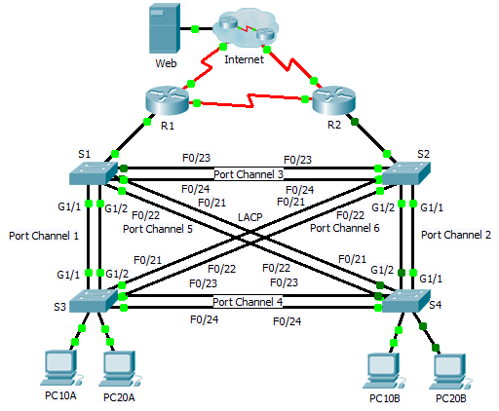

1. Addressing Table

|  |  |  |  |  |  |
| --- | --- | --- | --- | --- | --- |
| Device | Interface | IP Address | Subnet Mask | Default Gateway | VLAN Association |
| R1 | G0/0.1 | 192.168.99.1 | 255.255.255.0 | N/A | VLAN 99 |
| G0/0.10 | 192.168.10.1 | 255.255.255.0 | N/A | VLAN 10 |
| G0/0.20 | 192.168.20.1 | 255.255.255.0 | N/A | VLAN 20 |
| S0/0/0 | 209.165.22.222 | 255.255.255.224 | N/A | N/A |
| S0/0/1 | 192.168.1.1 | 255.255.255.0 | N/A | N/A |
| R2 | G0/0.1 | 192.168.99.2 | 255.255.255.0 | N/A | VLAN 99 |
| G0/0.10 | 192.168.10.2 | 255.255.255.0 | N/A | VLAN 10 |
| G0/0.20 | 192.168.20.2 | 255.255.255.0 | N/A | VLAN 20 |
| S0/0/0 | 192.168.1.2 | 255.255.255.0 | N/A | N/A |
| S0/0/1 | 209.165.22.190 | 255.255.255.224 | N/A | N/A |
| ISP | S0/0/0 | 209.165.22.193 | 255.255.255.224 | N/A | N/A |
| S0/0/1 | 209.165.22.161 | 255.255.255.224 | N/A | N/A |
| Web | NIC | 64.104.13.130 | 255.255.255.252 | 64.104.13.129 | N/A |
| PC10A | NIC | 192.168.10.101 | 255.255.255.0 | 192.168.10.1 | VLAN 10 |
| PC10B | NIC | 192.168.10.102 | 255.255.255.0 | 192.168.10.1 | VLAN 10 |
| PC20A | NIC | 192.168.20.101 | 255.255.255.0 | 192.168.20.1 | VLAN 20 |
| PC20B | NIC | 192.168.20.102 | 255.255.255.0 | 192.168.20.1 | VLAN 20 |

1. Scenario

In this activity, two routers are configured to communicate with each other. You are responsible for configuring subinterfaces to communicate with the switches. You will configure VLANs, trunking, and EtherChannel with PVST. The Internet devices are all preconfigured.

1. Requirements

You are responsible for configuring routers **R1** and **R2** and switches **S1**, **S2**, **S3**, and **S4**.

**Note:** Packet Tracer does not allow assigning point values less than 1. Since this activity is checking 154 items, not all configurations are assigned a point value. Click **Check Results** > **Assessment Items** to verify you correctly configured all 154 items.

Inter-VLAN Routing

On **R1** and **R2**, enable and configure the subinterfaces with the following requirement:

* 1. Configure the appropriate dot1Q encapsulation.
  2. Configure VLAN 99 as the native VLAN.
  3. Configure the IP address for the subinterface according to the Addressing Table.

Routing

Configure OSPFv2 using the following requirements:

* 1. User process ID 1.
  2. Advertise the network for each subinterface.
  3. Disable OSPF updates for each subinterface.

VLANs

* For all switches, create VLAN 10, 20, and 99.
* Configure the following static ports for **S1** and **S2**:
  1. F0/1 – 9 as access ports in VLAN 10.
  2. F0/10 – 19 as access ports in VLAN 20.
  3. F0/20 – F24 and G1/1 – 1/2 as the native trunk for VLAN 99.
* Configure the following static ports for **S3** and **S4**:
  1. F0/1 – 9 as access ports in VLAN 10.
  2. F0/10 – 20 as access ports in VLAN 20.
  3. F0/21 – F24 and G1/1 – 1/2 as the native trunk for VLAN 99.

EtherChannels

* All EtherChannels are configured as LACP.
* All EtherChannels are statically configured as the native trunk for VLAN 99.
* Use the following table to configure the appropriate switch ports to form EtherChannels:

|  |  |  |
| --- | --- | --- |
| Port Channel | Device: Ports | Device: Ports |
| 1 | S1: G1/1 – 2 | S3: G1/1 – 2 |
| 2 | S2: G1/1 – 2 | S4: G1/1 – 2 |
| 3 | S1: F0/23 – 24 | S2: F0/23 – 24 |
| 4 | S3: F0/23 – 24 | S4: F0/23 – 24 |
| 5 | S1: F0/21 – 22 | S4: F0/21 – 22 |
| 6 | S2: F0/21 – 22 | S3: F0/21 - 22 |

Spanning Tree

* Configure per-VLAN rapid spanning tree mode for all switches.
* Configure spanning tree priorities according to the table below:

|  |  |  |
| --- | --- | --- |
| Device | VLAN 10 Priority | VLAN 20 Priority |
| S1 | 4096 | 8192 |
| S2 | 8192 | 4096 |
| S3 | 32768 | 32768 |
| S4 | 32768 | 32768 |

Connectivity

* All PCs should be able to ping the **Web** and other PCs.